EDA Chief Executive for talks in Zagreb

Zagreb - 02 September, 2019

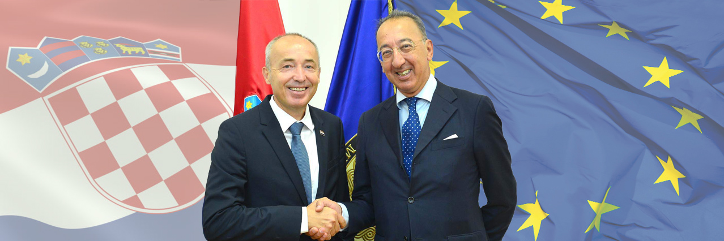

**Jorge Domecq, EDA Chief Executive, travelled to Zagreb for meetings with Damir Krstičević, Coatian Deputy Prime Minister and Minister of Defence, Gordan Grlić Radman, Minister of Foreign and European Affairs, Mirko Šundov, Chief of the General Staff, Croatian Armed Forces and other high-level representatives in the Croatian Ministry of Defence.**  
  
The main topics discussed during the bilateral meetings at the Croatian Ministry of Defence included the current state of play and way ahead in the implementation of the various EU defence initiatives (PESCO, CARD, European Defence Fund), the implementation of the revised EU Capability Development Priorities adopted in June 2018 and Croatia’s current and potential participation in EDA projects and programmes.    
  
Mr Domecq and Deputy Prime Minister Krstičević also discussed the defence and security priorities for the upcoming Croatian Presidency of the Council of the European Union.   
  
“*The focus in the defence range during the Croatian presidency will be placed on implementation of defence initiatives such as PESCO, CARD and military mobility, with the emphasis on their coherence and complementarity, as well as on the industrial dimension of defence (European Defence Fund) and on the enhanced NATO-the EU co-operation and further EU efforts in southeast Europe*“, said Minister Krstičević, who also announced a defence industry conference with the partners from the EU, during the Croatian presidency.   
  
“*EDA is deeply committed to supporting all its Member States, irrespective of their size. The current and upcoming Presidency are opportunities to further advance the embedding of the EU defence initiatives in the national defence plans and programmes with the aim of achieving a more collaborate, efficient and interoperable European defence*”, Jorge Domecq said. In particular, Mr Domecq confirmed the Agency’s interest to support the organisation of a high-level defence industry conference in the first half of 2020.   
  
Mr Domecq also had the opportunity to meet among others with with Robert Hranj, Vice Admiral, Director of the General Staff, Croatian Armed Forces, Zdravko Jakop, State Secretary, and Luka Barilović, President of Croatian Chamber of Commerce.